Assignment for 10-06-2020

# Assignment 1

**Description of problem:**: Animate an element, by changing its height and width.

**Sample Data:**

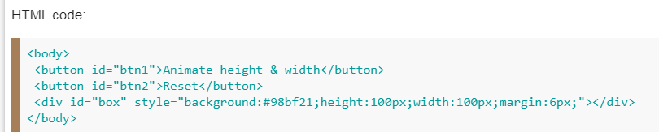

**Deliverable (s):** jQuery

**Format, Place, and Reference:** jQuery

# Assignment 2

**Description of problem:** Set a timer to delay the execution of subsequent items in the queue.

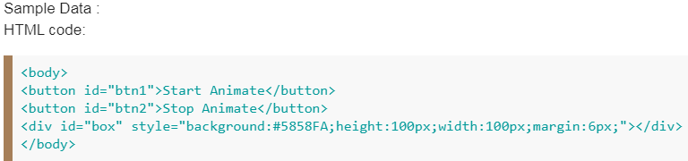

**Deliverable (s):** JQuery

**Format, Place, and Reference:** JQuery

# Assignment 3

**Description of problem:**:Run an animation with less frames.

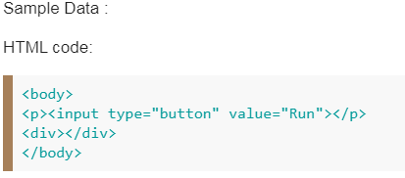

**Deliverable (s):** JQuery

**Format, Place, and Reference:** jQuery

**Note**: Please Submit your Assignment before 4 pm (11-06-2020).